# Preventing Tooth Decay in Children

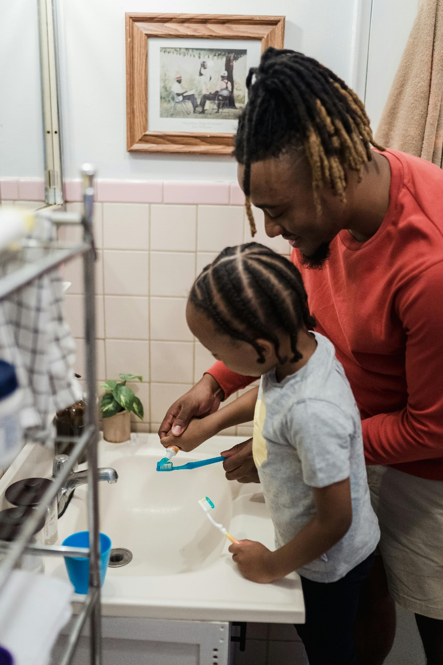Tooth decay is damage that occurs when bacteria in your mouth eats away at a tooth. This can cause a hole in the tooth called a cavity. If not treated, tooth decay and cavities can cause pain, infection and tooth loss.

Children, whose teeth are still growing, are more vulnerable than adults to tooth decay. This is because the minerals in baby teeth are not very strong and are easier for acids to eat away.

Bacteria from food are the main culprits of tooth decay. As the bacteria feed, they make acids. Without proper care, over time, these acids destroy tooth enamel (the hard outer layer of your tooth) causing tooth decay. Rest assured; tooth decay is highly preventable.

## Caring for your child's teeth

You can start caring for your baby’s gums a few days after birth by using a soft cloth to clean their gums. Do this until the first teeth come in.

As soon as you see the first baby (primary) tooth come in, start brushing your child's teeth twice a day using a small, soft brush. For children younger than three years, ask your dentist if it's okay to use a rice-sized amount of fluoride toothpaste. For children ages three to six years, use a pea-sized amount of fluoride toothpaste. It’s important to teach your child not to swallow the toothpaste.

**Brushing and flossing**

1. Kneel down or sit in a chair behind your child and have your child stand between your knees, facing away from you.

2. With one hand, gently press your child's head against your chest. You may also use that hand to push away the upper and lower lips to make it easier to get to the teeth.

3. With the other hand, brush your child's teeth using the proper technique. Place the toothbrush at a 45-degree angle where the teeth meet the gums. Press firmly, and gently rock the brush back and forth using small circular movements. Do not scrub.

4. Start flossing your child's teeth as soon as they touch each other. You may find plastic flossing tools helpful. Talk with your dentist about the right timing and technique to floss your child's teeth and how to teach your child to floss.

If your child is age six or older and has cavities, ask your dentist about fluoride mouthwash. Do not give your child a mouthwash that contains alcohol. The alcohol can be harmful if swallowed. From time to time, you may want to use disclosing tablets – chewable tablets that colour any plaque that remains after brushing. You can get these tablets at most drugstores.

Continue to help your child with brushing and check for proper cleaning until about age eight or older.

## Tips for getting kids to brush

Although some children quickly learn to brush their teeth, others do not. If you are having trouble getting your child to brush, try some of these:

* Use a favourite toy to explain why it's important to brush. You can encourage your child to brush the toy's teeth after brushing their own teeth.
* Use rewards such as stickers every time they brush.
* Let your child pick out a special toothbrush and toothpaste.

v

## Wellness Articles

Alberta Health Services encourages all Albertans to live a healthy life. These weekly Wellness Articles are created by a team of healthcare professionals from AHS in collaboration with   
provincial healthcare experts in Alberta and content from myhealth.alberta.ca.   
Our experts ensure this information is factual, current, and written for Albertans.

From stress-relief strategies to finding balance within your life, these Wellness Articles cover a   
variety of different topics designed to inspire and educate Albertans on creating a positive and   
healthy lifestyle.

We welcome and encourage weekly newspapers, community newsletters and other publications   
to reproduce this information free of charge. Please credit Alberta Health Services or the identified   
content provider.

If you would like to be added to the distribution list for these articles, please email: **rebecca.johnson2@ahs.ca**. You will receive a monthly email containing articles for the   
upcoming four weeks.