# Tips for a Healthier Relationship with Social Media and News

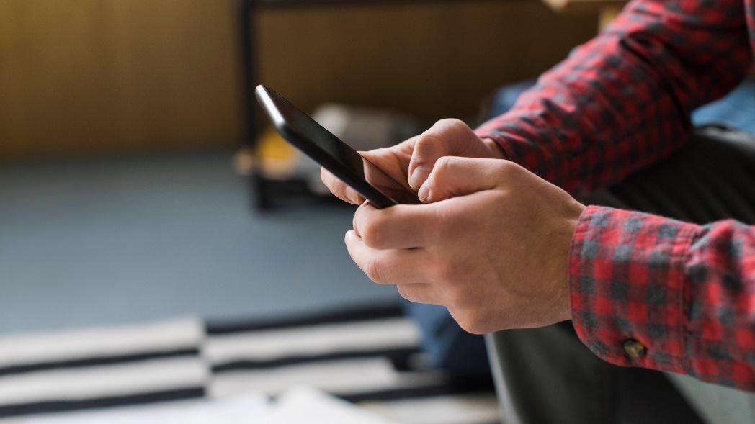Social media and news can help you stay connected. But all that information can also be overwhelming. It can disrupt your day. And it's easy to form habits you didn't mean to.

Be sure to stay safe while using social media. Be careful with the information you share and who you share it with when you’re online. If someone is harassing or threatening you, unfriend or remove them from your friends list, block them, and report them to the site administrator. Learn about how to use the privacy settings on social media and keep your security software up to date.

## Tips to consume social media and news in a healthy way

* **Know your goal.**If you want to use social media to stay up-to-date on community events, log off after you have the info you need. If you're trying to stay caught up on the day's events, do you need to keep an eye on the headlines all day? Maybe a check-in once a day is enough.
* **Notice how it makes you feel.**Does seeing what friends are sharing make you happy? Or does it make you feel down? Does the daily news stress you out? When you know how news and social media affect you, you can decide if you need to make some changes to how you use them.
* **Don't compare your everyday life to someone else's online life.**People usually post about the shiny parts of their lives instead of daily struggles or disappointments. So even if what you're seeing is a true story, remember that it won't be the whole story. Add to your life and learning with real-world experience.
* **Change notification settings.** That way you can find information you want when you're ready for it, instead of letting it find you.
* **Unfollow and hide feeds as needed.** If accounts you follow or friends you have post things that stress you out, get rid of them. If you don't want to "unfriend" someone, just change your settings so that you don't see what they post anymore. They'll never know.
* **Follow the feel-good stuff.** The news can be heavy. Try to find balance by focusing on things that make you feel happy. Try following social media accounts that are focused on your interests or on things that make you laugh. And sign up for "good news" mailers. Most major news outlets offer them, or something like it. To help you find balance try tracking how much time you spend on social media or reading news.
* **Set a time to step away**. Make time to disconnect from news and social media. Close your apps and turn off the TV. Read a book, get outside, work on a puzzle, or call a friend. It doesn't matter what you choose to do. Just make sure it's something that feels supportive and worth your time.

v

## Wellness Articles

Alberta Health Services encourages all Albertans to live a healthy life. These weekly Wellness Articles are created by a team of healthcare professionals from AHS in collaboration with   
provincial healthcare experts in Alberta and content from myhealth.alberta.ca.   
Our experts ensure this information is factual, current, and written for Albertans.

From stress-relief strategies to finding balance within your life, these Wellness Articles cover a   
variety of different topics designed to inspire and educate Albertans on creating a positive and   
healthy lifestyle.

We welcome and encourage weekly newspapers, community newsletters and other publications   
to reproduce this information free of charge. Please credit Alberta Health Services or the identified   
content provider.

If you would like to be added to the distribution list for these articles, please email: **rebecca.johnson2@ahs.ca**. You will receive a monthly email containing articles for the   
upcoming four weeks.